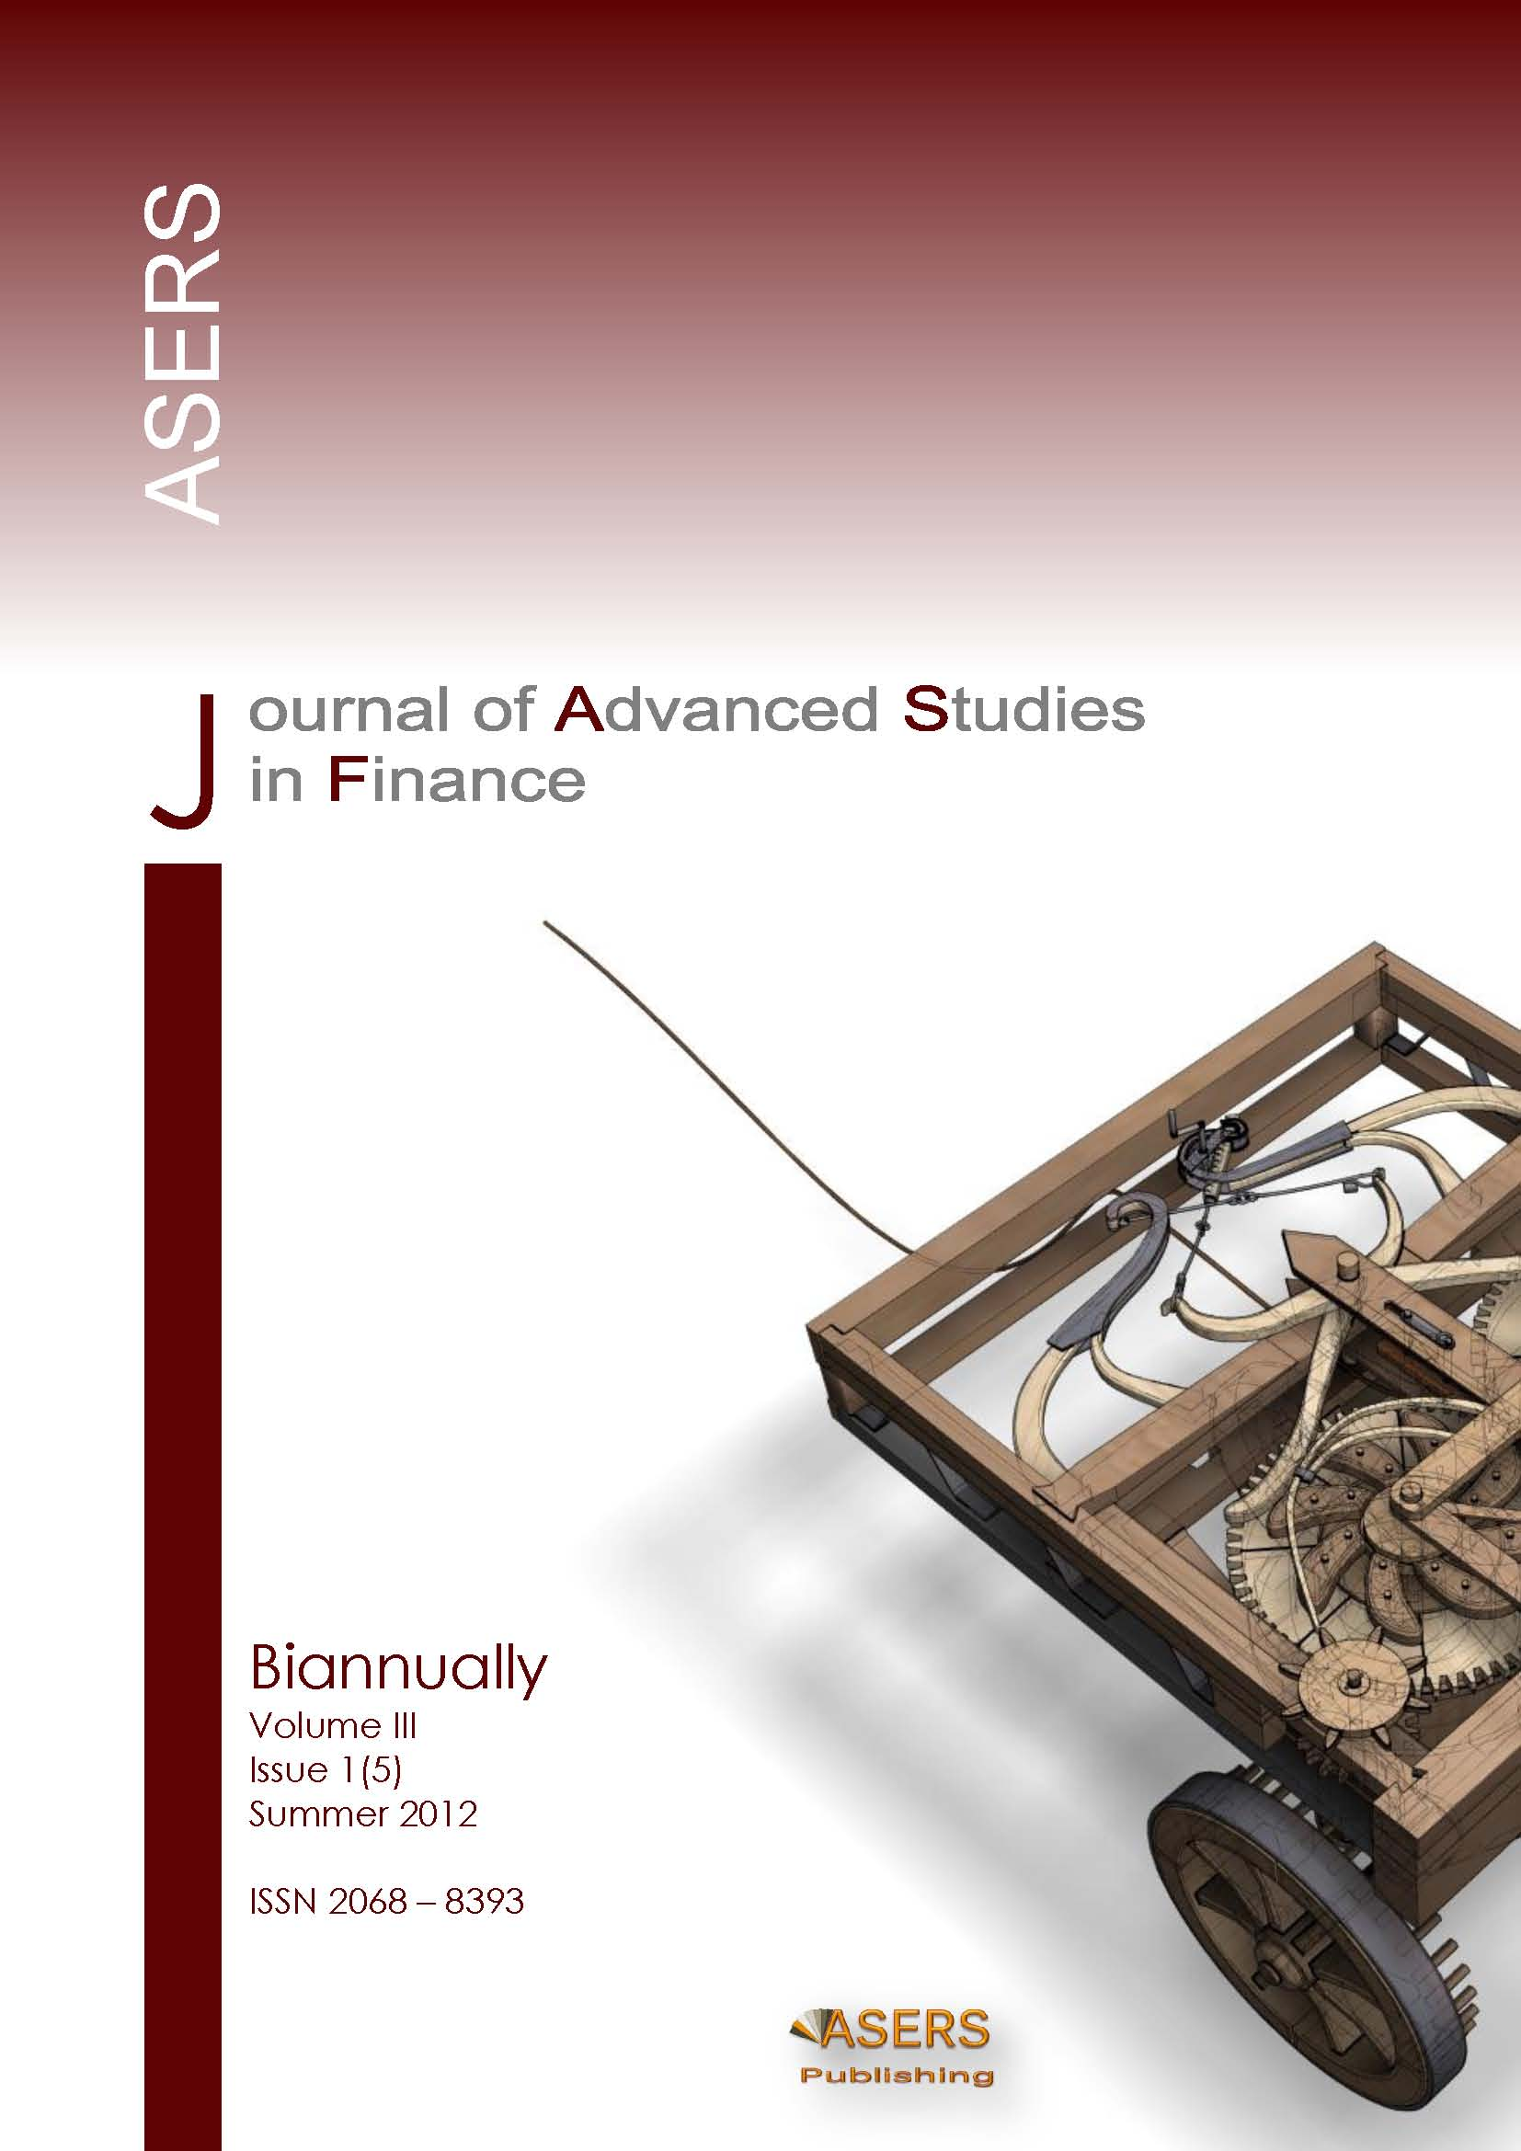
Address: 7, Eugeniu Carada Street, Craiova, 200390
e-mail: apg@aserspublishing.eu
Website: www.aserspublishing.eu

ASERS Publishing House Copyright Agreement

This Agreement refers to the manuscript of the article having the title and the authors as below:
The Title of the Article (hereinafter, ‘Article’): _________________________________________________________________
______________________________________________________________________________________________________
Author(s): #1. First name: ________________________________Last name: _______________________________________
#2. First name: ________________________________Last name: _______________________________________
#3. First name: _________________________________Last name: _______________________________________
#4. First name: _________________________________Last name: _______________________________________
From which, corresponding author:
First name: _________________________________Last name: _______________________________________

to be published by ASERS Publishing House (hereinafter ‘Publisher’), for publishing in Journal of Advanced Studies in Finance, ISSN: 2068-7729, Journal DOI: https://doi.org/10.14505/jasf, website: http://journals.aserspublishing.eu/jasf, e-mail: jasf@aserspublishing.eu

Non-Exclusive License:
We hereby grant to ASERS Publishing House (‘Publisher’) a non-exclusive license to publish and distribute the article(s) referenced above and any supplemental tables, illustrations or other information submitted therewith that are intended for publication as part of the article (the ‘Article’) in all forms and media (whether now known or hereafter developed), throughout the world, in all languages, for the full term of copyright, effective when and if the ‘Article’ is accepted for publication. This license includes the right to provide the ‘Article’ in electronic and online forms and systems. With respect to supplemental data that we wish to make accessible through a link in the ‘Article’, we hereby grant a non-exclusive license for such linking. If we have agreed with the ‘Publisher’ to make available such supplemental data on a site or through a service of ASERS Publishing, we hereby grant a non-exclusive license for such publication, posting and making available, and further permit indexing and archiving.
We agree that the ‘Publisher’ shall have first publication rights in the ‘Article’ and that ASERS Publishing retains exclusive rights in the definitive final version of the ‘Article’ that appears in the Newsletter and embodies all value-adding publisher activities including copy-editing, formatting and (if relevant) pagination (‘the Published Article’). With respect to versions of the Article other than the Published Article, if we reproduce or authorize reproduction of the Article following publication, ASERS Publishing will be acknowledged as the first publisher of the Article and a link to the appropriate bibliographic citation (authors, newsletter, article title, volume issue, page numbers, DOI, and the link to the Published Article on ASERS Publishing’ Platform) should be maintained.

Authorship:
If copyright is held by the employer, the employer or an authorized representative of the employer must sign. If the corresponding author signs, it is understood that this is with the authorization of the employer and the employer's acceptance of the terms of the transfer. Please confirm by marking the appropriate box following the signature line.

Author Warranties:
The undersigned Author(s) of the above-mentioned ‘Article’ here transfer any and all copyright-rights of the ‘Article’ to the ‘Publisher’. The Author(s) warrants that the ‘Article’ is based on their original work and that the undersigned has the power and authority to make and execute this assignment. It is the author's responsibility to obtain written permission to quote material that has been previously published in any form. The ‘Publisher’ recognizes the retained rights noted below and grants to the above authors and employers for whom the work performed royalty-free permission to reuse their materials below. Authors may reuse all or portions of the above ‘Article’ in other works, excepting the publication of the ‘Article’ in the same form. Authors may reproduce or authorize others to reproduce the above ‘Article’ for the Author's personal use or for internal company use, provided that the source and ‘Publisher’ copyright notice are mentioned, that the copies are not used in any way that implies the ‘Publisher’ endorsement of a product or service of an employer, and that the copies are not offered for sale as such. Authors are not permitted to grant third party requests for reprinting, republishing or other types of reuse of the published ‘Article’. The Authors may make limited distribution of all or portions of the above ‘Article’ prior to publication if they inform The ‘Publisher’ of the nature and extent of such limited distribution prior there to. Authors retain all proprietary rights in any process, procedure, or article of manufacture described in the ‘Article’. This agreement becomes null and void if and only if the above ‘Article’ is not accepted and published by the ‘Publisher’, or is withdrawn by the author(s) before acceptance by the ‘Publisher’.
If the ‘Article’ was prepared jointly with other authors, the corresponding author have informed the co-author(s) of the terms of this Copyright Agreement and that he/she is signing on their behalf as their agent, and represent that he/ she is authorized to do so.

Authorized Signature (of corresponding author): ________________________________________________________________

Full Name of corresponding author (printed): ___________________________________________________________________

Company or institution: ____________________________________________________________________________________

Title (if employer representative): ____________________________________________________________________________

Signature of the Employer for whom work was done, if any: _______________________________________________________

Please mark the box if the following applies: Employer representative

Date:_________________

Third Party(ies) Signature(s) (if necessary): __________________________________

Please e-mail a scanned copy of the completed and signed original of this Copyright Agreement (retaining a copy for your file) to jasf@aserspublishing.eu

On behalf of ASERS Publishing House, 7, Eugeniu Carada Street, Craiova, 200390.

